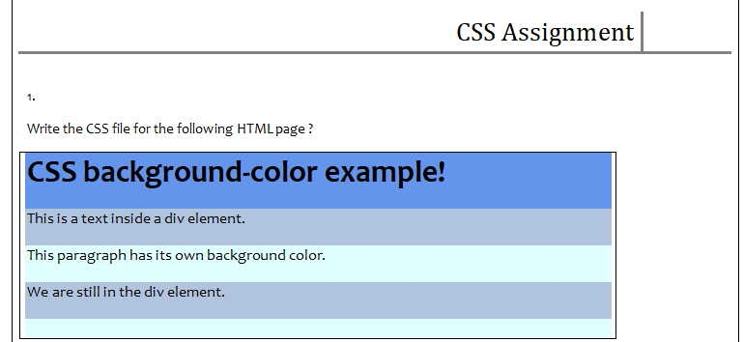

<head>  
 <meta charset="UTF-8">  
 <title>CSS ASSIGN</title>  
 <link rel="stylesheet" href="newcss.css">  
</head>  
<body>  
<div>  
<h1>CSS Background-color example</h1>  
  
 <p class="first">this is a text inside a div element</p>  
 <p class="second">this paragraph has its own backgrond color</p>  
 <p class="third">we are still in a div element</p>  
</div>  
</body>

This is CSS file with name newcss.css

h1  
{  
 background-color:Blue;  
}  
div  
{  
 background-color:#34eba4;  
}  
div .first  
{  
 background-color:#34e8eb;  
}  
div .third  
{  
 background-color:#34e8eb;  
}

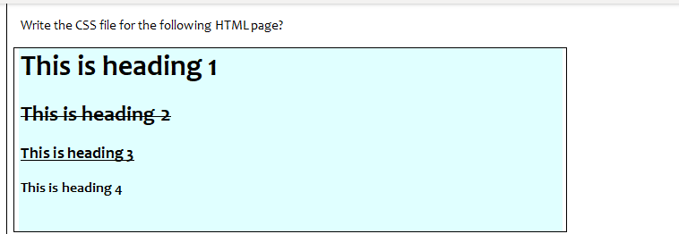

<head>  
 <meta charset="UTF-8">  
 <title>CSS ASSIGN</title>  
 <link rel="stylesheet" href="newcss.css">  
</head>  
<body>  
<h2>This is heading 1</h2>  
 <h4>This is heading 2</h4>  
 <h5>This is heading 3</h5>  
</body>

Here I have linked newcss.css in head section

div{  
background-color:lightblue;  
border: 1px solid black;  
}

h2{  
text-decoration:line-through;  
}  
h4{  
text-decoration: underline;  
}  
h5{  
text-decoration:bold;  
}

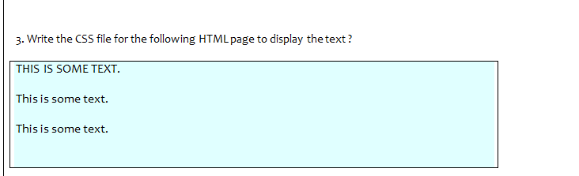

<div>  
 <p class="first">THIS IS SOME TEXT</p>  
 <p>This is some text</p>  
 <p class="diff">This is some text</p>  
</div>

**#Css file name newcss.css has this content**

div{  
background-color:lightblue;  
border: 1px solid black;  
}  
p .first  
{  
font: strong;  
}

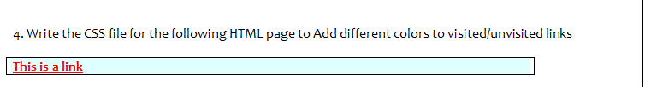

<a href="">This is a link</a>

a:visited {  
 color: pink;  
}  
a:active {  
 color: yellow;  
 text-decoration: underline;  
}

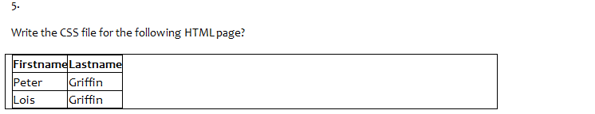

<table>  
 <tr>  
 <th>  
 First Name  
 </th>  
 <th>  
 Last Name  
 </th>  
 </tr>  
 <tr>  
 <td>  
 Peter  
 </td>  
 <td>  
 Griffin  
 </td>  
 </tr>  
 <tr>  
 <td>  
 Lois  
 </td>  
 <td>  
 Griffin  
 </td>  
 </tr>  
</table>

th,td{  
border:1px solid black;  
}

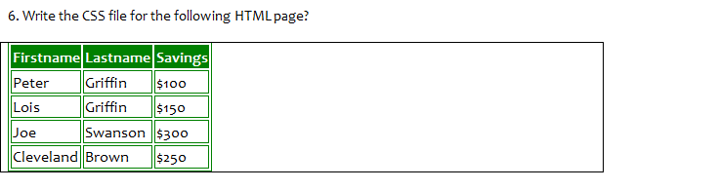

<table>  
 <tr>  
 <th>  
 First Name  
 </th>  
 <th>  
 Last Name  
 </th>  
 <th>  
 Saving  
 </th>  
 </tr>  
 <tr>  
 <td>  
 Peter  
 </td>  
 <td>  
 Griffin  
 </td>  
 <td>  
 $100  
 </td>  
 </tr>  
 <tr>  
 <td>  
 Lois  
 </td>  
 <td>  
 Griffin  
 </td>  
 <td>  
 $150  
 </td>  
 </tr>  
 <tr>  
 <td>  
 Joe  
 </td>  
 <td>  
 Swanson  
 </td>  
 <td>  
 $300  
 </td>  
 </tr>  
 <tr>  
 <td>  
 Cleveland  
 </td>  
 <td>  
 Brown  
 </td>  
 <td>  
 $250  
 </td>  
 </tr>  
</table>  
th,td{  
border:2px solid green;  
}  
th{  
background-color:green;  
}

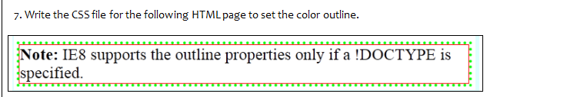

<div class="first">  
 <div class="second">  
 <div class="third">  
 <div class="fourth">  
 <h2>Note: IE8 supports the outline properties Only if !Doctype is specified</h2>  
 </div>  
 </div>  
 </div>  
</div>  
###########################################################

div .fourth  
{  
border: 1px solid red;  
}  
div .third  
{  
border: 4px dotted green;  
}  
div .second  
{  
border: 4px solid lightblue;  
}

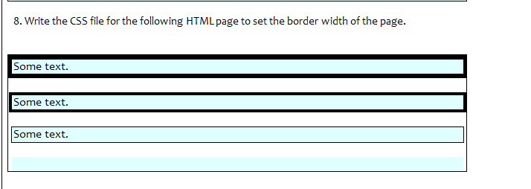

<div class="mainsection">  
 <p class="first">  
 Some text is here  
 </p>  
 <p class="second">  
 Some text is here  
 </p>  
 <p class="third">  
 Some text is here  
 </p>  
 <p class="forth">  
  
 </p>  
</div>

Content of Css file---🡪

.mainsection  
{  
border: 1px solid black;  
}  
.first  
{  
 background-color: lightblue;  
 border: 5px solid black;  
}  
.second  
{  
 background-color: lightblue;  
 border: 3px solid black;  
}  
.third  
{  
 background-color: lightblue;  
 border: 2px solid black;  
}  
.forth  
{  
 background-color: lightblue;  
 border: 8px solid lightblue;  
}